**User Guide**

**Group 15**

April 26th, 2020

**Team Members**

Domonic Neal

Ny Tran

Ronny Soto

Contents [2](https://docs.google.com/document/d/1KkPYBjz5yCS42tPaSgdy7TzZReaDkemP/edit#heading=h.35nkun2)

1 Introduction [3](https://docs.google.com/document/d/1KkPYBjz5yCS42tPaSgdy7TzZReaDkemP/edit#heading=h.1ksv4uv)

2. Sign into Guest Network [3](https://docs.google.com/document/d/1KkPYBjz5yCS42tPaSgdy7TzZReaDkemP/edit#heading=h.1fob9te)

2.1 Windows 10 3

2.2 Mac OS X 5

2.3 Android 6

2.4 iOS 7

3 Sign into Company Network 8

3.1 Windows 10 8

3.2 Mac OS 8

3.3 Android 8

3.4 iOS 9

4 System Requirements [9](https://docs.google.com/document/d/1KkPYBjz5yCS42tPaSgdy7TzZReaDkemP/edit#heading=h.1y810tw)

5 Main Scenarios of Use 9

5.1 Accessing the Guest Network 9

5.2 Accessing the Company Network 9

6 Troubleshooting 10

6.1 Incorrect Password for Guest network 10

6.2 Incorrect Username/Password for Company network 10

# **1 Introduction**

The purpose of this project is to build a secure network for three locations and the headquarter of the company. This document will provide a user guide for getting into the guest network.

# **2 Sign into Guest Network**

## ***2.1 Windows 10***

1. On the system tray, click on the **Wireless** User-added image icon.
2. Select your Guest network.

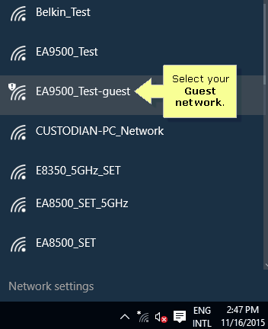

1. Click the Connect button.

**QUICK TIP**: You can check the Connect automatically box to enable the computer to connect automatically the next time it is within the range of the Guest network.

1. Select the browser you wish to use, then click OK. In this example, the Microsoft Edge browser is used.

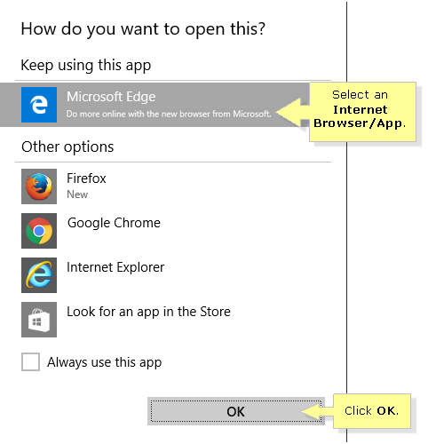

**QUICK TIP**: Alternatively, you can check Always use this app to enable the computer to automatically use the desired browser the next time you connect to another Guest network.

1. You will be directed to the Guest Access login page. Enter the Guest network password.

**QUICK TIP**: If the Guest Access login page does not appear, there may be a problem with your web browser.

1. After logging in, you should be able to access the Internet.

## ***2.2 Mac OS X***

* + - 1. Click the **Wi-Fi User-added image** icon.

**NOTE**: Make sure that the Wi-Fi is turned ON.

* + - 1. Select your wireless network name (SSID) from the list of available wireless networks.

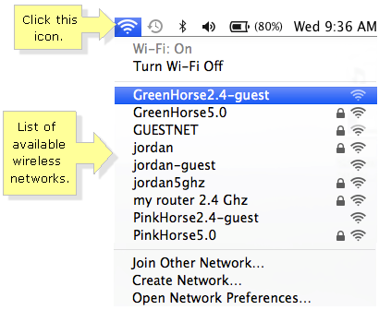

* + - 1. Open any web browser. You will be directed to the Guest Access login page. Enter the Guest network password.
      2. After logging in, you should be able to access the Internet.

## ***2.3 Android***

1. Open your phone's Settings app.
2. Tap Network & internet And then Wi-Fi.
3. Turn on Wi-Fi.
4. Tap the Guest network.
5. Open any web browser. You will be directed to the Guest Access login page. Enter the Guest network password.

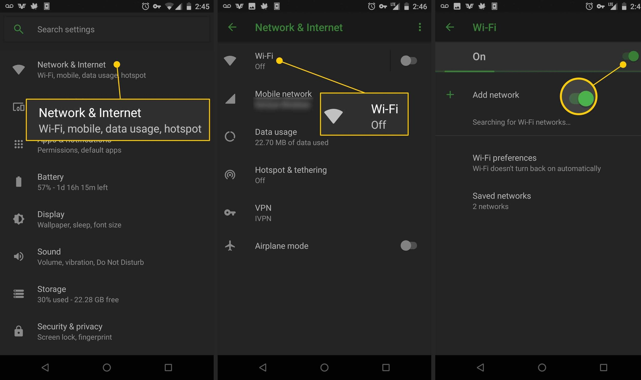

## ***2.4 iOS***

* 1. From your Home screen, go to Settings > Wi-Fi.
  2. Turn on Wi-Fi. Your device will automatically search for available Wi-Fi networks.
  3. Tap the name of the Wi-Fi network that you want to join.
  4. Open Safari. You will be directed to the Guest Access login page. Enter the Guest network password.

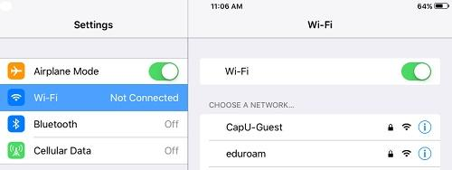

# **3 Sign into Company Network**

## ***3.1 Windows 10***

* + 1. Click wireless network icon in the notification area at the bottom right of the window to login to the network.
    2. In the list, click on the Company Wifi, and press "Connect."

**QUICK TIPS**: If you click "connect automatically", and next time your system will be automatically connected.

* + 1. Enter your company username and password, then press "OK."
    2. Open any web browser and accept the "Terms of Use and Disclaimer" of the Company network, press “OK.”

## ***3.2 Mac OS X***

* + 1. Click wireless network icon  in notification area at the top right of the window to login to the network
    2. In the list, click on the Company Wifi, and press "Connect."
    3. Enter your company username and password, then press "OK."
    4. Open any web browser and accept the "Terms of Use and Disclaimer" of the Company network, press “OK.”

## ***3.3 Android***

* + 1. select "Settings" > select "Wi-Fi".
    2. Switch on the "Wi-Fi" function, select the Company network.
    3. Type and select the following information, press "Connect".
       1. EAP: PEAP
       2. Identity: Your Username
       3. Password: Your Password
    4. Click "Sign into Wi-Fi network"
    5. Activate the browser and accept the "Terms of Use and Disclaimer" of the Company network.

## ***3.4 iOS***

* + 1. Select "Settings" > Select "Wi-Fi".
    2. Switch on "Wi-Fi" function > Select the Company network.
    3. Enter your username and password for Company network, then press "Join".
    4. Trust Company certificate.
    5. Activate the browser and accept the "Terms of Use and Disclaimer" of the Company network.

# **4 System Requirements**

The Guest network and Company network should be accessible by any laptop windows vista and above and Mac OS X and any iOS and Android 4.0+. Refer to the System Documentation for instructions on installation.

# **5 Main Scenarios of Use**

## ***5.1 Accessing the Guest network***

Refer to section 2 to access the Guest network.

## ***5.2 Accessing the Company network***

Refer to Section 3 to access the Company network

# **6 Troubleshooting**

## ***6.1 Accessing the Guest network***

A message will be displayed in the event incorrect login information is entered. Try again with proper credentials to access the Guest network. If trouble is encountered, retrieve proper login information directly from a representative.

## ***6.1 Accessing the Guest network***

A message will be displayed in the event incorrect login information is entered. Try again with proper credentials to access the Company network. If trouble is encountered, contact the network admin.

# 